User Story

As an evaluator, I want the site to be accessible so that special needs people can access the site.

Specifically this means adding alternate text to the lead generation, brand awareness and cost management sections of the HTML.

Aceptance Criteria

Make the site fully functionable. For example, there is currently a bug in the link to the search engine optimization section, where if the user clicks on search engine optimization in the header, they are not redirected to the search engine optimization section of the page. Also make sure alternate text is displayed if the image is unavailable in the lead generation, brand awareness and cost management sections of the HTML.

Mock Ups

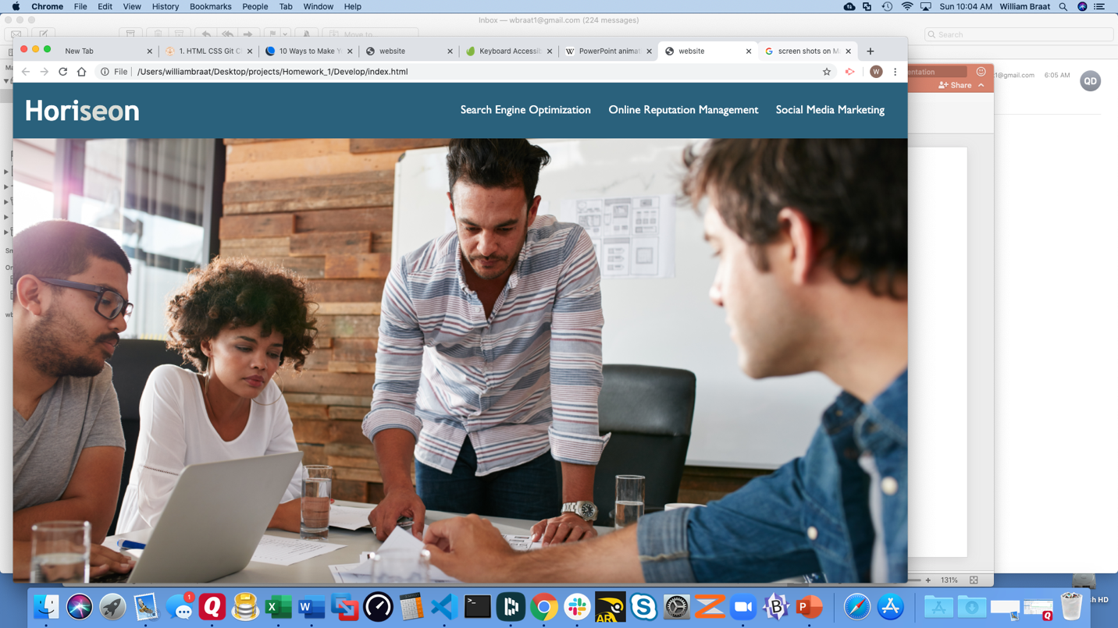

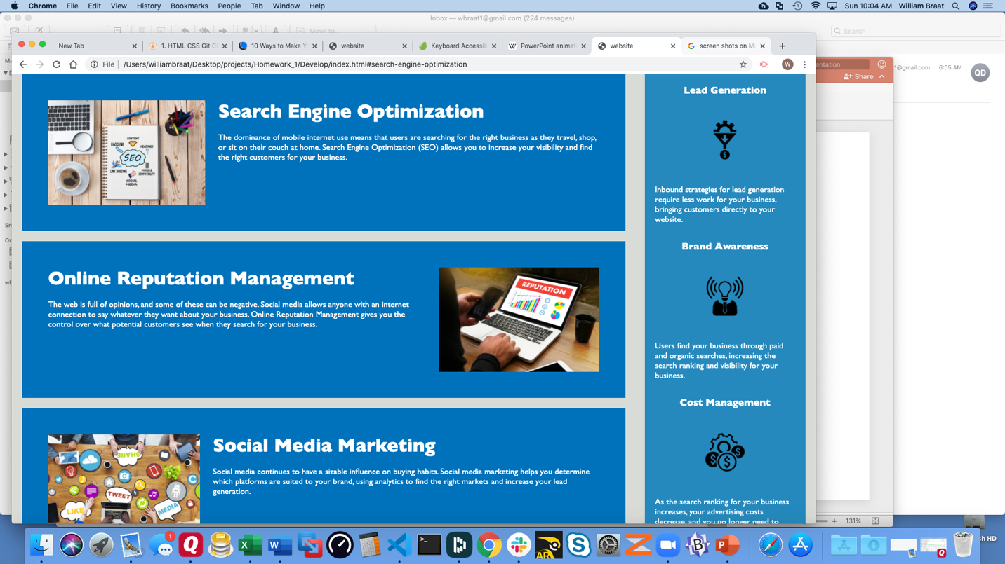

Submission